# PROFESSIONAL TRAINING REPORT

**at**

**Sathyabama Institute of Science and Technology (Deemed to be University)**

Submitted in partial fulfillment of the requirements for the award of Bachelor of Engineering Degree in Computer Science and Engineering

By

## NAME: KASARAM HARSHAVARDHAN

**(Reg.No.40110565)**

****

**DEPARTMENT OF COMPUTER SCIENCE AND ENGINEERING SCHOOL OF COMPUTING**

**SATHYABAMA INSTITUTE OF SCIENCE AND TECHNOLOGY JEPPIAAR NAGAR, RAJIV GANDHI SALAI,**

**CHENNAI – 600119, TAMILNADU**

**OCT 2022**

1

**SATHYABAMA**

**INSTITUTE OF SCIENCE AND TECHNOLOGY**

### (DEEMED TO BE UNIVERSITY)

**Accredited with Grade “A” by NAAC**

**(Established under Section 3 of UGC Act, 1956)**

**JEPPIAAR NAGAR, RAJIV GANDHI SALAI, CHENNAI– 600119**

**[www.sathyabamauniversity.ac.in](http://www.sathyabamauniversity.ac.in/)**

# DEPARTMENT OF COMPUTER SCIENCE AND ENGINEERING

**BONAFIDE CERTIFICATE**

This is to certify that this Project Report is the Bonafide work of **KASARAM HARSHAVARDHAN (40110565)** who carried out the project entitled **“Aggregation On Student Mid-Term Data”** under my supervision from Aug 2022 to Oct 2022.

## Internal Guide Ms.V.Gowri Manohari M.E.(Ph.D)

**Head of the Department Dr. L. Lakshmanan M.E., PH. D**



## Submitted for Viva voce Examination held on

**Internal Examiner External Examiner**

2

**DECLARATION**

I **KASARAM HARSHAVARDHAN** (**40110565**) hereby declare that the Project Report entitled “**Aggregations On Student Mid-Term Data**” done by me under the guidance of **MS. V.Gowri Manohari** **M.E.(Ph.D)**is submitted in partial fulfillment of the requirements for the award of Bachelor of Engineering degree in Computer Science and Engineering.

## DATE:

**PLACE: SIGNATURE OF THE CANDIDATE**

3

**ACKNOWLEDGEMENT**

I am pleased to acknowledge my sincere thanks to **Board of Management of SATHYABAMA** for their kind encouragement in doing this project and for completing it successfully. I am grateful to them.

I convey my thanks to **Dr. L. Lakshmanan M.E., Ph.D.**, **Dean**, School of Computing **Dr. S. Vigneshwari M.E., PH.D., and Dr. T. Sasikala M.E., Ph.D.,** Heads of the Department of Computer Science and Engineering for providing me necessary support and details at the right time during the progressive reviews.

I would like to express my sincere and deep sense of gratitude to my Project Guide **MS. V.Gowri Manohari** for her valuable guidance, suggestions and constant encouragement paved way for the successful completion of my project work.

I wish to express my thanks to all Teaching and Non-teaching staff members of the **Department of Computer Science and Engineering** who were helpful in many ways for the completion of the project.

4

TRAINING CERTIFICATE



# ABSTRACT

The definition of aggregate data is a collection of information from

multiple individuals that is summarized into an official data report.

The data is collected from individuals with a shared commonality, like

geographical location, association with an organization, or something

else of interest. What is aggregate data used for, and what does

aggregate data mean for those that compile aggregate data? The

purpose is to collect data on as many individuals as possible, so

statistical analysis of the data can make predictions, estimate trends,

assess policies, and find average values for some factor within the

population of interest.

**Methods for statistical analysis**

Aggregate data may be represented as either descriptive data or

numerical data. In either case, the goal is to summarize the

information in some meaningful way. One way to do so is by finding

some sort of average value, represented in statistics by calculating

the mean, median, and mode.

6

|  |  |  |
| --- | --- | --- |
|  | **TABLE OF CONTENTS** |  |
| **CHAPTER No.** | **TITLE** | **PAGE No** |
|  | ABSTRACT | i |
|  | LIST OF FIGURES | ii |
|  |  |  |
|  |
|  |  |
| **1** | **INTRODUCTION** |  |
|  | 1.1 INTRODUCTION | **9** |
|  | 1.2 AGGREGATION ON  STUDENT MID TERM DATA | **10** |
| **2.** | **AIM AND SCOPE OF THE PRESENT INVESTIGATION** | **11** |
|  | 2.1 Aim |  |
|  | 2.2 Objective  2.3 Features of MySQL  2.4 Versions of MySQL |  |
| **3.** | **EXPERIMENTAL OR MATERIALS AND METHODS; ALGORITHMS USED** | **14** |
|  | 3.1 CREATING A DATABASE  FOR SQL SERVER INSTANCE |  |
| **4.** | **SUMMARY AND**  **CONCLUSIONS** | **24** |
|  | **REFERENCES** | **25** |
|  | **APPENDIX** |  |
|  | A.SCREENSHOTS | **26** |
|  | B. SOURCE CODE | **36** |

7

# LIST OF FIGURES

**FIGURE NO. FIGURE NAME PAGE NO.**

1.1 working of data aggregations **9**

1.2 Types of data aggregations **10**

8

# Chapter 1

# Introduction:

# ****AGGREGATION:** The word Aggregate data** refers to numerical or non-numerical information that is (1) collected from multiple sources and/or on multiple measures, variables, or individuals and (2) compiled into data summaries or summary reports, typically for the purposes of public reporting or statistical analysis—i.e., examining trends, making comparisons, or revealing information and insights that would not be observable when data elements are viewed in isolation. For example, information about whether individual students graduated from high school can be aggregated—that is, compiled and summarized—into a single graduation rate for a graduating class or school, and annual school graduation rates can then be aggregated into graduation rates for districts, states, and countries.

# Lightbox

# Fig:1.1 Working of data aggregations

# To further illustrate the concept of aggregate data and how it may be used in public education, consider a school with an enrollment of 500 students, which means the school maintains 500 student

# 9

# records, each of which contains a wide variety of information about

# the enrolled students—for example, first and last name, home address, date of birth, gender identification, race or ethnicity, date and period of enrollment, courses taken and completed, course-grades earned, test scores, etc. (the information collected and maintained on individual students is often called [student mid-term data](https://www.edglossary.org/student-level-data/" \t "_blank), among other terms)

# There are two types of data aggregations:

# Time

# Spatial

# Lightbox

# Fig:1.2 types of data aggregations

# 

# 10

# Chapter 2

# 2.1 Aim:

# Aggregating the student mid-term data using mysql.

# 2.2 Objective:

* features of MySQL
* versions of MySQL
* Applications of Data aggregation

**2.3 THE FEATURES OF MYSQL**

* RDS for MySQL supports most of the features and capabilities of MySQL. Some features might have limited support or restricted privileges.

**Supported storage engines for RDS for MySQL**

While MySQL supports multiple storage engines with varying capabilities, not all of them are optimized for recovery and data durability. Amazon RDS fully supports the InnoDB storage engine for MySQL DB instances. Amazon RDS features such as Point-In-Time restore and snapshot restore require a recoverable storage engine and are supported for the InnoDB storage engine only

* 1. **VERSIONS OF MYSQL**

# For MySQL, version numbers are organized as version = X.Y.Z. In the terminology, X.Y denotes the major version, and Z is the minor version number. For implementations, a version change is considered major if the major version number changes—for example, going from version 5.7 to 8.0. A version change is considered minor if only the minor version number changes—for example, going from version 8.0.27 to 8.0.30.

11

**Applications of Data Aggregation:**

Data aggregation is used in many fields where a large number of datasets are involved. It helps in making fruitful decisions in marketing or finance management. It helps in the planning and pricing of products.

Efficient use of data aggregation can help in the creation of marketing schemes. E.g. If the company is performing ad campaigns on a particular platform, they must deeply analyze the data to raise sales. The aggregation can help in analyzing the execution over a respective time period of campaigns or a particular cohort or a particular channel/platform. This can be done in three steps namely Extraction, Transform, Visualize.

**Expressions:** It refers to the name of the field in input documents for e.g. { $group : { \_id : “$id“, total:{$sum:”$marks“}}} here $id and $marks are expressions.

**Accumulators:** These are basically used in the group stage

## SQL Aggregate Functions

* **sum:** It sums numeric values for the documents in each group
* **count:** It counts total numbers of documents
* **avg:** It calculates the average of all given values from all documents
* **min:** It gets the minimum value from all the documents
* **max:** It gets the maximum value from all the documents
* **first:** It gets the first document from the grouping
* **last:** It gets the last document from the grouping

# 13

# Chapter 3

# 3.1 Aggregations on student midterm data

# 

# 

# 14

# 

# 

# 15

# 

# 

# 16

# 

# 17

# 

# 

# 18

# 

# 

# 19

# 

# 

# 20

# 

# 

# 21

# 

# 

# 

# 22

**Chapter 4**

Summary and Conclusion

Summary:

## A relational database is a collection of data items with pre-defined relationships between them. These items are organized as a set of tables with columns and rows. Tables are used to hold information about the objects to be represented in the database. Each column in a table holds a certain kind of data and a field stores the actual value of an attribute. The rows in the table represent a collection of related values of one object or entity. Each row in a table could be marked with a unique identifier called a primary key, and rows among multiple tables can be made related using foreign keys. This data can be accessed in many different ways without reorganizing the database tables themselves

## Conclusion:

Aggregate functions are a very powerful tool in databases. They serve the same purpose as their equivalents in MS Excel, but the magic is that you can query data and apply functions in the same statement. Today, we’ve seen basic examples. Later in this series, we’ll use them to solve more complicated problems (with more complicated queries), so stay tuned.

# 24

External Reference:

[https://www.section.io/engineering-education/aggregation-in-dbms/#conclusion](https://www.section.io/engineering-education/aggregation-in-dbms/" \l "conclusion)

https://geeksforgeeks.org/aggregation-in-mongodb.html

<https://study.com/learn/lesson/aggregate-data.html>

25

Appendix:

Screenshots

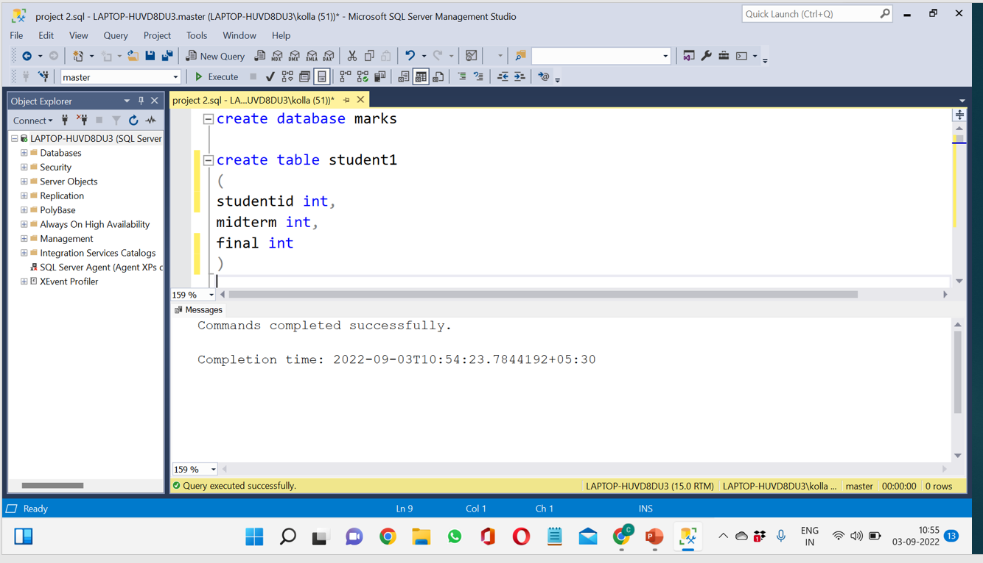

26

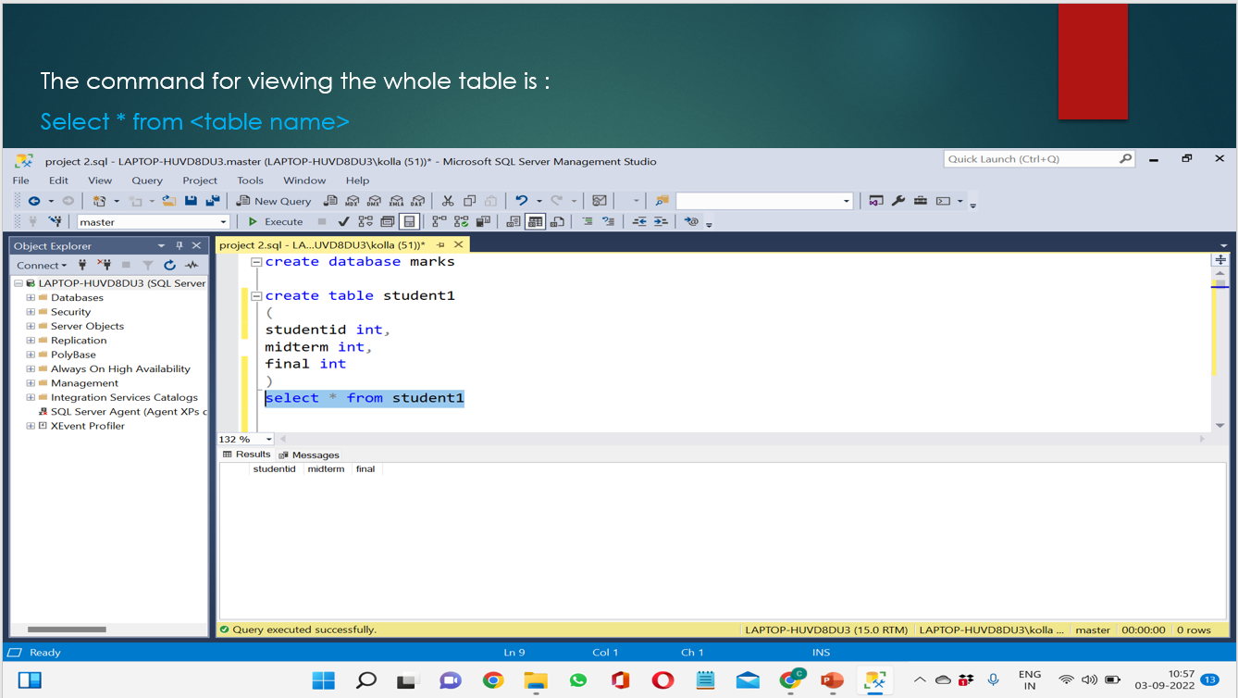

27

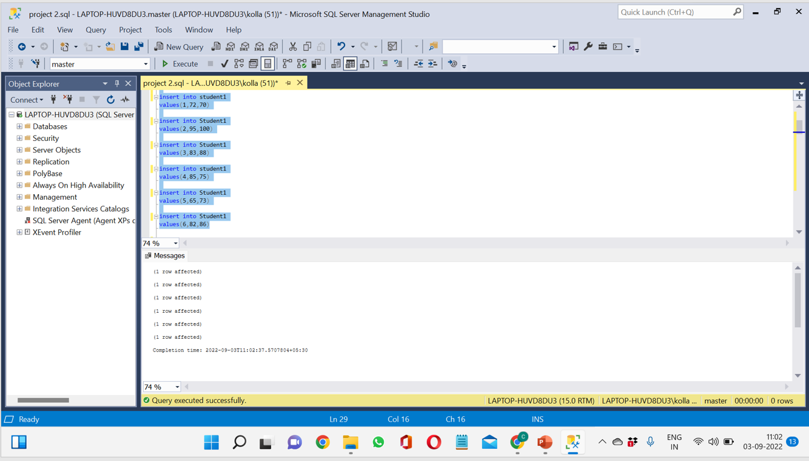

28

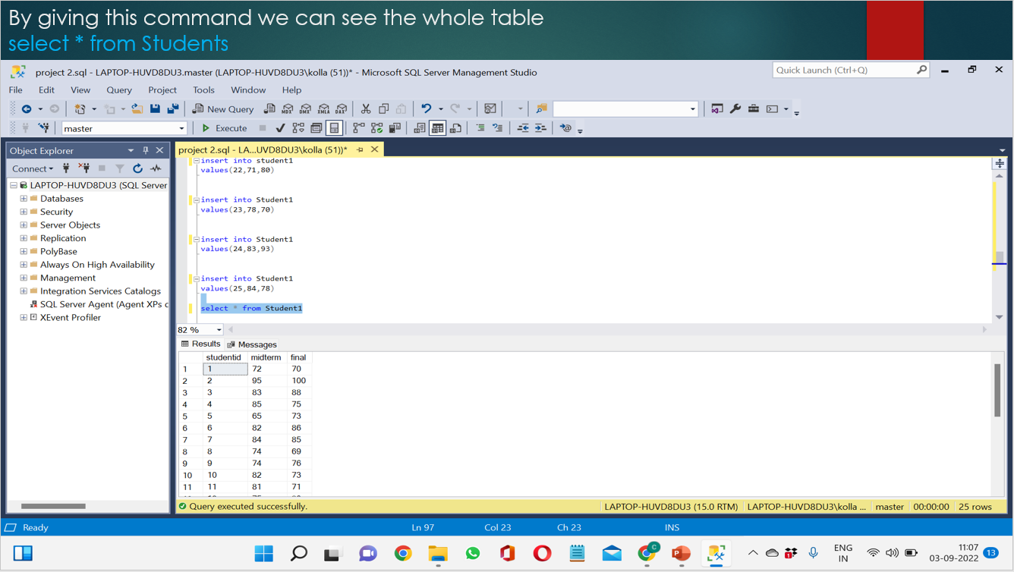

29

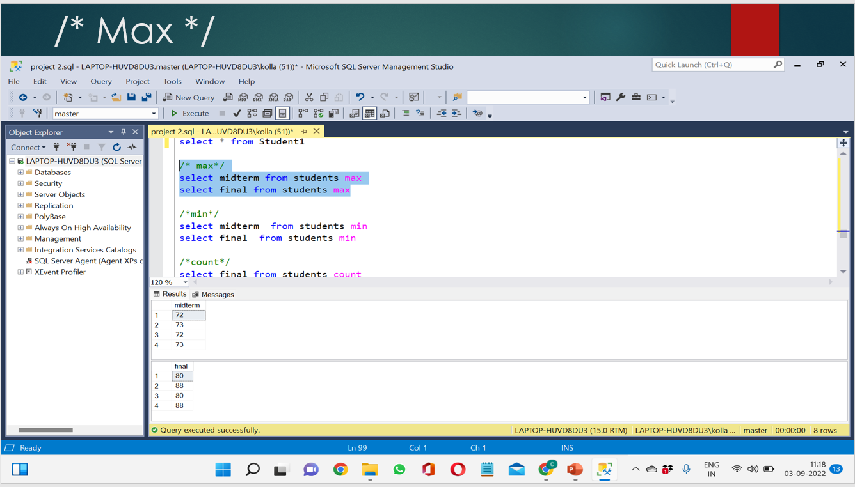

30

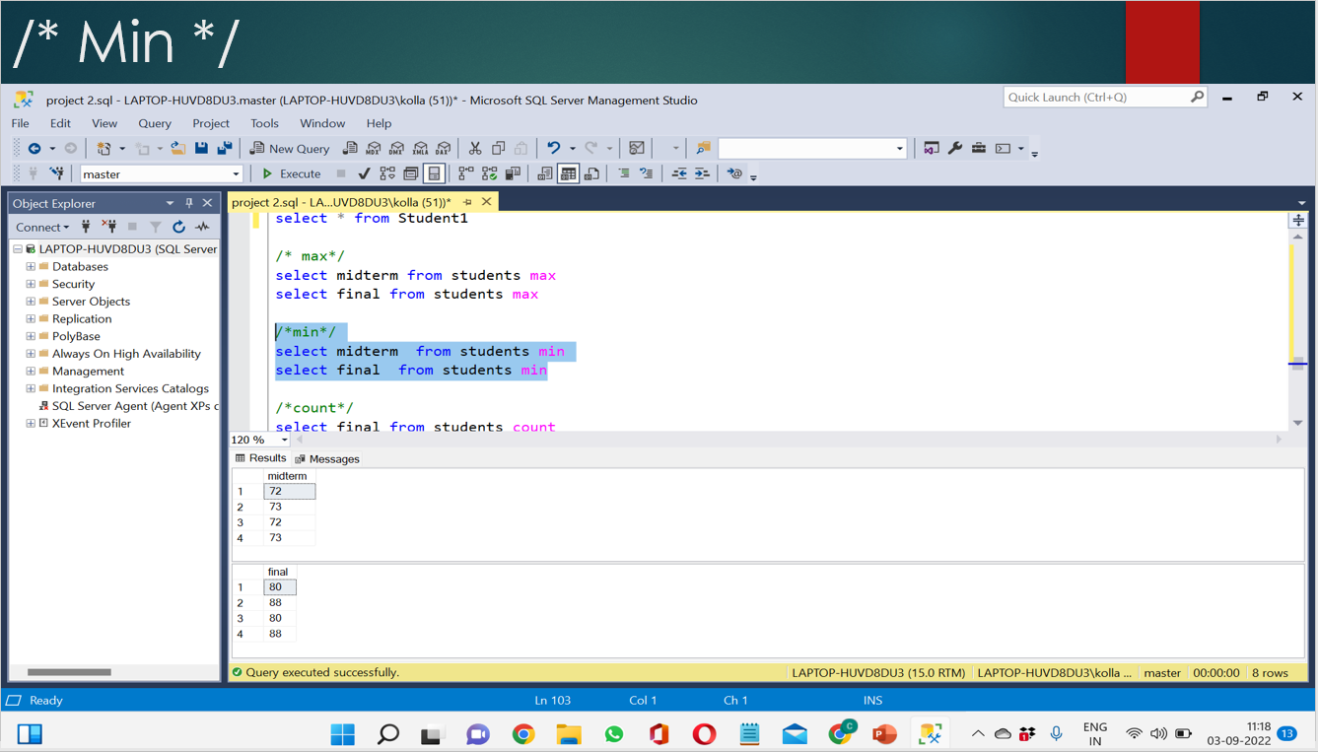

31

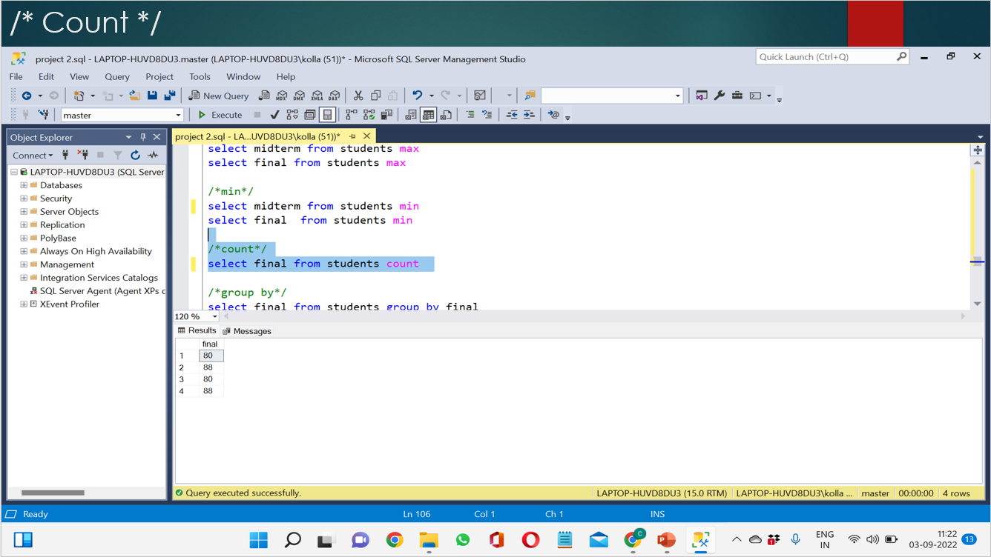

32

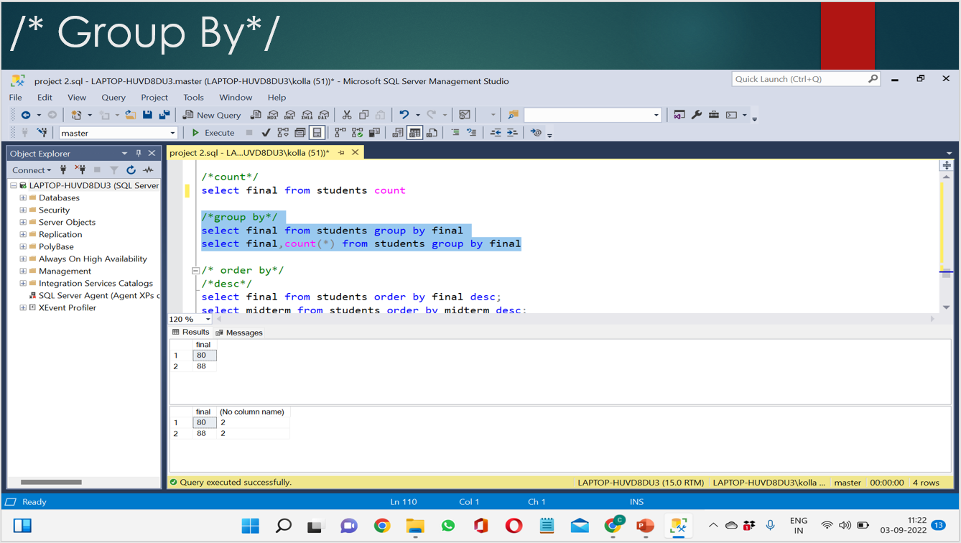

33

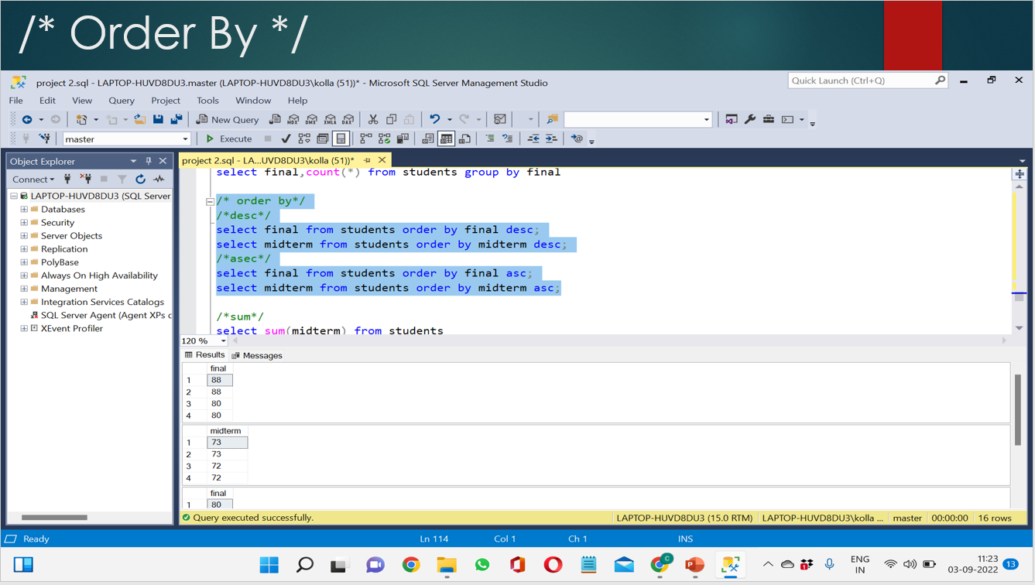

34

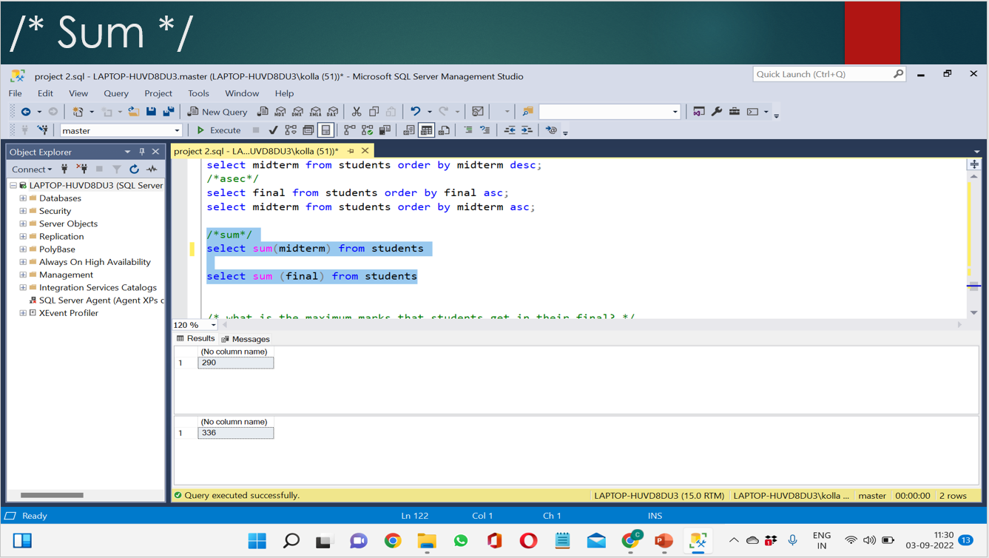

35

SOURCE CODE:

create database marks

create table student

(studentid int,

midterm int,

final int)

insert into Student

values(1,72,70)

insert into Student

values(2,95,100)

insert into Student

values(3,83,88)

insert into Student

values(4,85,75)

insert into Student

values(5,65,73)

insert into Student

values(6,82,86)

36

insert into Student

values(7,84,85)

insert into Student

values(8,74,69)

insert into Student

values(9,74,76)

insert into Student

values(10,82,73)

insert into Student

values(11,81,71)

insert into Student

values(12,75,80)

insert into Student

values(13,78,72)

insert into Student

values(14,78,63)

insert into Student

values(15,72,68)

insert into Student

37

values(16,73,83)

insert into Student

values(17,75,79)

insert into Student

values(18,79,69)

insert into Student

values(19,72,76)

insert into Student

values(20,75,70)

insert into Student

values(21,77,74)

insert into Student

values(22,71,80)

insert into Student

values(23,78,70)

insert into Student

values(24,83,93)

insert into Student

38

values(25,84,78)

select \* from Student

/\* max\*/

select midterm from students max

select final from students max

/min/

select midterm from students min

select final from students min

/count/

select final from students count

/group by/

select final from students group by final

select final,count(\*) from students group by final

/\* order by\*/

/desc/

select final from students order by final desc;

select midterm from students order by midterm desc;

/asec/

39

select final from students order by final asc;

select midterm from students order by midterm asc;

/sum/

select sum(midterm) from students

select sum (final) from students

/\* what is the maximum marks that students get in their final? \*/

select final max from students

/\* what is the minimum marks that students get in their midterm? \*/

select midterm min from students

40

select \* from Student\_mid\_term\_data

--- how to perform a min aggregation operation on Midterm ?

select min(Midterm) as final from Student\_mid\_term\_data

select \* from Student\_mid\_term\_data

--- how to perform a max aggregation operation on Midterm ?

select max(Midterm) as final from Student\_mid\_term\_data

select \* from Student\_mid\_term\_data

--- how to perform a count aggregation operation on Midterm ?

select count(\*) as final from Student\_mid\_term\_data

select \* from Student\_mid\_term\_data

--- how to perform a group by aggregation operation on Midterm ?

select Student,sum(Midterm) as final from Student\_mid\_term\_data

group by student

select \* from Student\_mid\_term\_data

--- how to perform a order by aggregation operation on Midterm ?

select Midterm,final from Student\_mid\_term\_data

order by Midterm asc

select \* from Student\_mid\_term\_data

--- how to perform sum aggregation operation on Midterm ?

select sum(Midterm) as final from Student\_mid\_term\_data

41

THANK YOU